Task 11

Registry and INI files
For many applications there are settings and configuration information that is used to customise the program to user system or preferences. In order to do this registry setting or configuration from an ‘INI’ file

INI File access
The example code that follows shows how to interface into the kernel dynamic link library to access ‘INI’ settings. There are three items that can change for accessing file information. These are as follows.
Item | Example | Comment
File name | App.Path & App.ProductName &”.ini” | Could use more than one file for different pieces of information.
Section | “AlarmClock” | Can have more than one section per file.
Key | “Hour” | Can have more than one key per section.
The three items change for each piece of information within the application. It is usual to have all the information for a program to be in the same file. The Section key is then used to separate different pieces of information such as recent file list, program behaviour such as the previous use of the program or the location of a data base file. Each section is then sub-divided by the key from which the value can be obtained or set.
The example code that follows is contained in two sections. The module code which has functions to access to the ‘INI’ file and the form code which is used to demonstrate the correct performance of the code.

Module code for access to ‘INI’ files
Note that the file written to is being determined from the application product name therefore before running the program remember to set the product name within the project settings.
Declare Function GetPrivateProfileString Lib "kernel32" _
Alias "GetPrivateProfileStringA" _
(ByVal lpApplicationName As String, _
ByVal lpKeyName As Any, _
ByVal lpDefault As String, _
ByVal lpReturnedString As String, _
ByVal nSize As Long, _
ByVal lpFileName As String) As Long
Declare Function WritePrivateProfileString& Lib "kernel32" _
Alias "WritePrivateProfileStringA" _
(ByVal AppName$, _
ByVal KeyName$, _
ByVal keydefault$, _
ByVal Filename$)
Public Sub SetIni(Section As String, _
key As String, Value As String)
Dim retval As String
Dim worked As Integer
Dim Filename As String
Filename = App.Path & "\" & App.ProductName & ".ini"
retval = String$(255, 0)
If 0 = WritePrivateProfileString(Section, _
key, Value, Filename) Then
MsgBox "Failed", vbExclamation
End If
End Sub
Public Function GetIni(Section As String, key As String) As String
Dim retval As String
Dim worked As Integer
Dim Filename As String
Filename = App.Path & "\" & App.ProductName & ".ini"
retval = String$(255, 0)
worked = GetPrivateProfileString(Section, _
key, "", retval, Len(retval), Filename)
If worked = 0 Then
MsgBox "Failed", vbExclamation
GetIni = ""
Else
GetIni = Left(retval, InStr(retval, Chr(0)) - 1)
End If
End Function

Test Form code
The form used to test the ‘INI’ file access contains four text boxes all with the name texttest and indices zero to 3.
Option Explicit
Private Sub Form_Load()
Call MnuRead_Click
End Sub
Private Sub Form_Resize()
Dim h As Single
Dim i As Integer
h = ScaleHeight / 4
For i = 0 To 3
TextTest(i).Move 0, i * h, ScaleWidth, h
Next i
End Sub
Private Sub MenuWrite_Click()
Dim i As Integer
For i = 0 To 3
Call SetIni("databaseFile", "PathA" & Str(i), _
TextTest(i).Text)
Next i
End Sub
Private Sub MnuClear_Click()
Dim i As Integer
For i = 0 To 3
TextTest(i).Text = ""
Next i
End Sub
Private Sub MnuRead_Click()
Dim i As Integer
For i = 0 To 3
TextTest(i).Text = GetIni("databaseFile", _
"PathA" & Str(i))
Next i
End Sub

Registry entry access
For registry entries there are similar application, section and Key divisions for the different registry entries. These sets of registry setting are only in the Visual Basic application section of the registry. But there are different sets per user of the program, since the registry entry is with a user profile.
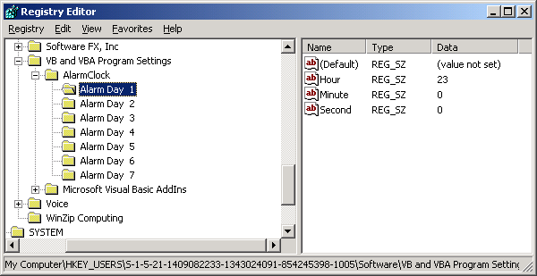
For an application registry the following code example could be used. This example is for the application developed in Task 6 saving the alarm time when the Clock Form is loaded and unloaded. The two string constants are used to maintain consistency within the registry access. Use the help system to lookup the syntax information for both the functions ‘GetSetting’ and ‘SaveSetting’.

Private Const ThisApp As String = "AlarmClock"
Private Const AppKey As String = "AlarmTIME"
Private Sub Form_Load()
' recall settings from the registry.
Alarm_hour = GetSetting(ThisApp, AppKey, "Hour", 0)
Alarm_minute = GetSetting(ThisApp, AppKey, "Minute", 0)
Alarm_second = GetSetting(ThisApp, AppKey, "Second", 0)
End Sub
Private Sub Form_Unload(Cancel As Integer)
' Place settings in the registry.
Call SaveSetting(ThisApp, AppKey, "Hour", Alarm_hour)
Call SaveSetting(ThisApp, AppKey, "Minute", Alarm_minute)
Call SaveSetting(ThisApp, AppKey, "Second", Alarm_second)
End Sub

Exercises
- Modify the Alarm clock program to access the have a different alarm time for each day of the week. Use both an ‘INI’ file and a registry setting for the alarm storage.
- Modify the Vending machine program to access information that is to be saved between runnings of the program.
- Look at other applications to add registry recording of the information between times the program is run. This could be a recent files list or default values for a form.

